# CS 255 System Design Document Template

This template lays out all the different sections that you need to complete for Project Two. Each section has guidance to prompt your thinking. You will need to continually reference the interview transcript as you work to make sure that you are addressing your client’s needs. There is no required length for the final document. Instead the goal is to complete each section based on what your client’s needs are. Remove this note when you are finished, and replace all bracketed text with the relevant information.

## UML Diagrams

### UML Use Case Diagram

### UML Activity Diagrams

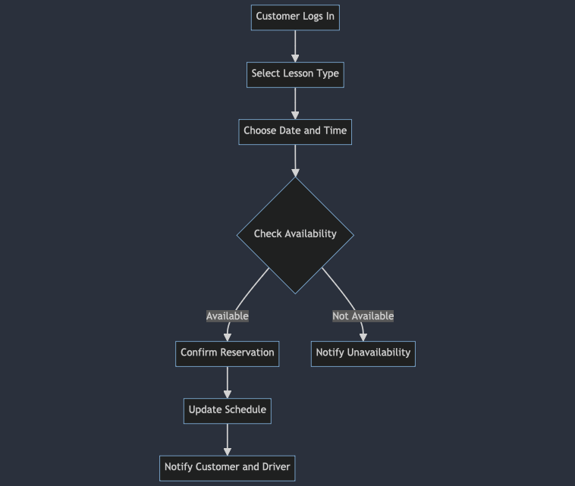

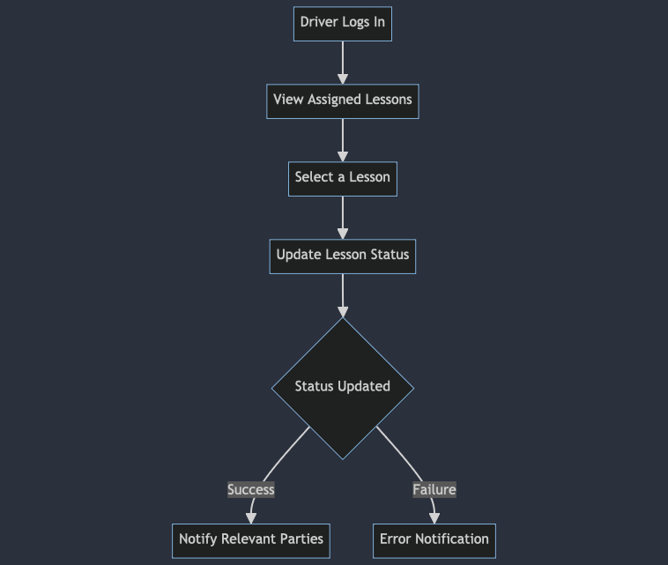

### UML Sequence Diagram

### UML Class Diagram

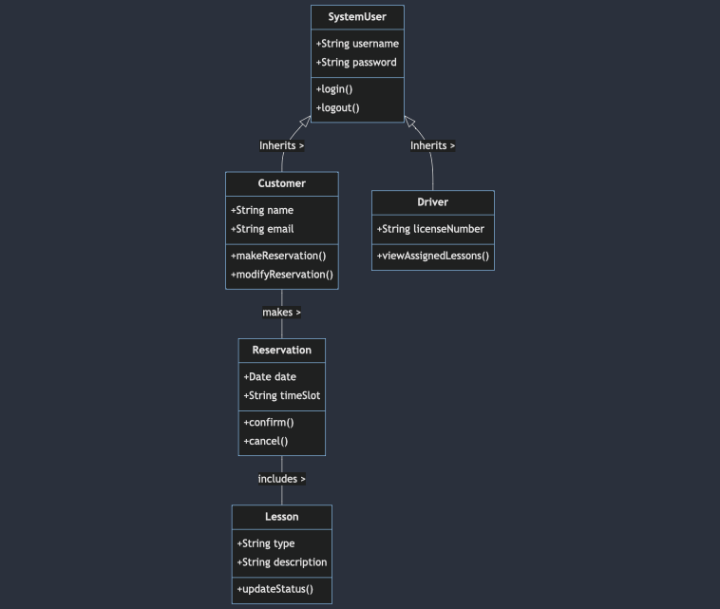

## Technical Requirements

1. ***Hardware:*** *Servers for hosting the application and database;*

*user devices; computers or smartphones for accessing the system.*

1. ***Software:***
   * *Database management system for storing reservation, customer, and lesson data.*
   * *Web server software for hosting the application.*
   * *Development frameworks and languages for building the application (e.g., Java, .NET).*
2. ***Tools:***
   * *Integrated Development Environment (IDE) for coding (e.g., Visual Studio, Eclipse).*
   * *Version control system (e.g., Git).*
3. ***Infrastructure:***
   * *Network infrastructure for online connectivity.*
   * *Security infrastructure like firewalls and SSL certificates for secure data transmission.*
   * *Cloud services for scalability and reliability.*